**IMPORTS AND EXPORTS**

**Country-wise India Exports by Commodity**

**Name: Syed Ahmad Hussain**

1. **Introduction**
   1. **Overview**

Foreign trade Includes Import and Export. Importing means buying foreign goods and services by citizens, businesses and government of a country. No matter, how they are sent to the country. They can be shipped, sent it by e-mail, or even hand carried in personal luggage on a plane. A country importing more than it’s export, runs a trade deficit. Whereas, a country importing less than it’s exports, create a trade surplus.

Exporting means goods and services which are produced in one country are purchased in another country. It is produced domestically and sold to someone in a foreign country. Most countries want to increase their exports as it increases the GDP of the country.

In India At the level of Central Government it is administered by the Ministry of Commerce and Industry.

Prior to the 1991 economic liberalisation, India was a closed economy due to the average tariffs exceeding 200 percent and the extensive quantitative restrictions on imports. Foreign investment was strictly restricted to only allow Indian ownership of businesses. Since the liberalisation, India's economy has improved mainly due to increased foreign trade.

This project aims to analyse India’s Country wise Exports by Commodities. The analysis is made over the years 2011-12 and 2012-13. The project analyses various products exported to various countries. It also analyses the commodities with whose exports, India gains max profits. The commodity quantities and values exported are compared country-wise to determine which country exports is most profitable for India.

* 1. **Purpose**

The Purpose of this project is to analyse the relation between between countries and profits. Values in Rupees can be compared with the countries to determine which country produces the Highest value. This can be used to promote more exports to the country and increase India’s returns on foreign trade. Commodities having most probability of producing higher gains are also analysed in this project and can also be used to increase India’s foreign trade Income.

1. **Literature Surveys**
   1. **Existing problem**

* Existing systems cannot determine the maximum profits per country.
* They cannot compute the export returns of each commodity with the country
  1. **Proposed Solution**

The project proposes an analysis of exports with countries and commoditites exported with each country.

1. **Theoritical Analysis** 
   1. **Block Diagram**
   2. **Hardware/Software Designing**

Hardware Requirements:

* RAM: 8GB
* Disk Space: min 2GB

Software Requirements:

* OS : Windows 7, MacOS High Sierra
* Tableau Desktop Professional 2021.1
* Tableau Public
* Git Hub
* Microsoft Excel
* Imports and Exports Data set

**6 Results**

**6.1 Map Depicting India’s Country wise exports for the commodity**

The map depicts the Country with which India exports a commodity. The Commodity selected from the Parameter drop down is used to filter India’s exports based on the selected commodity

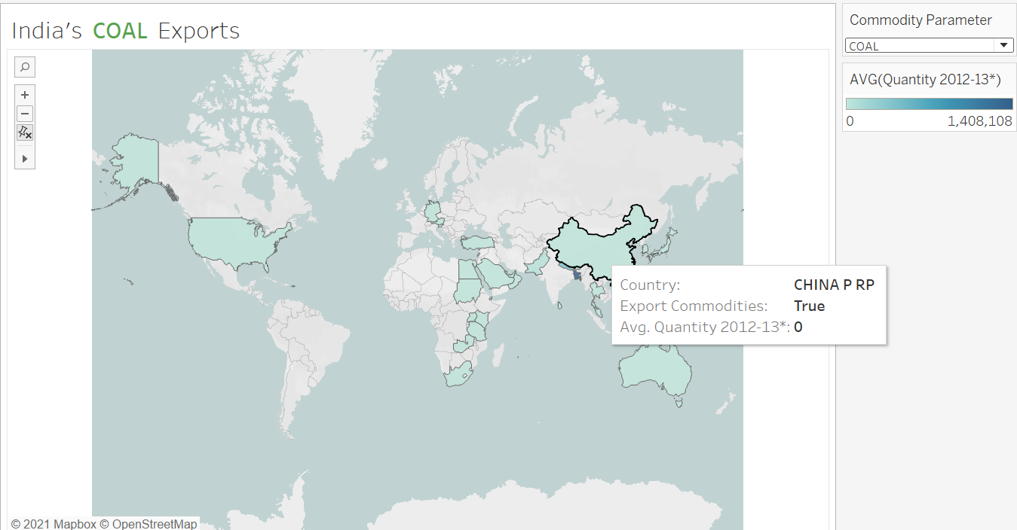

**6.2 Comparing Commodity values over years**

The commodity Value gains are compared for the top 10 commodities having highest Gains (in INR).

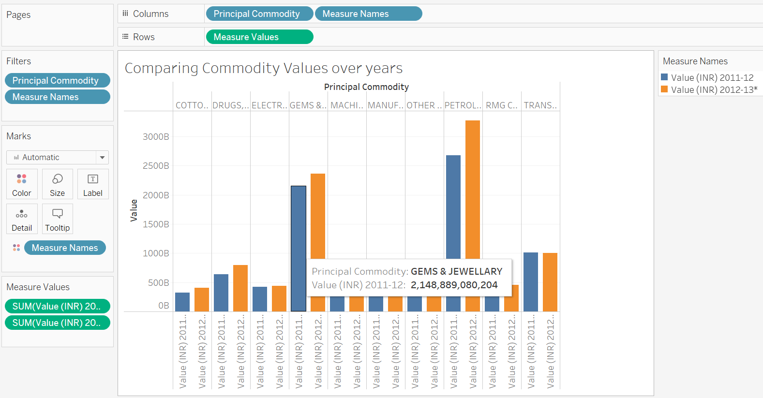

**6.3 Countries to which India has exported max Commodities**

The Bubble chart depicts the Countries for which india has the highest no of exports based on Commodity.

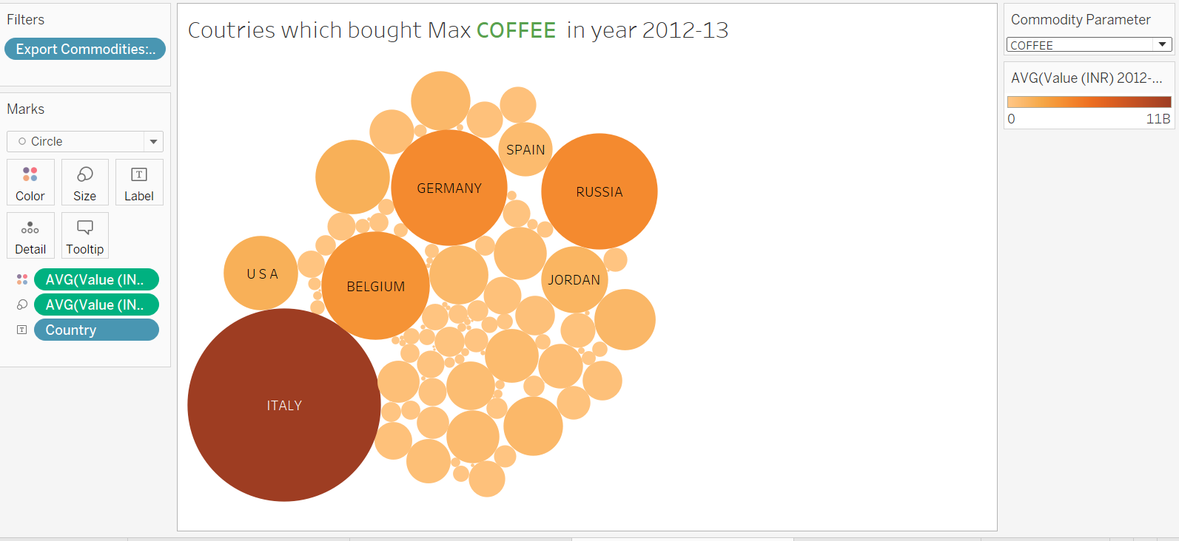

**6.4 Comparing Quantities exported to 10 countries yielding high export returns over 2 years**

The line chart compares the exports of countries over the two years.

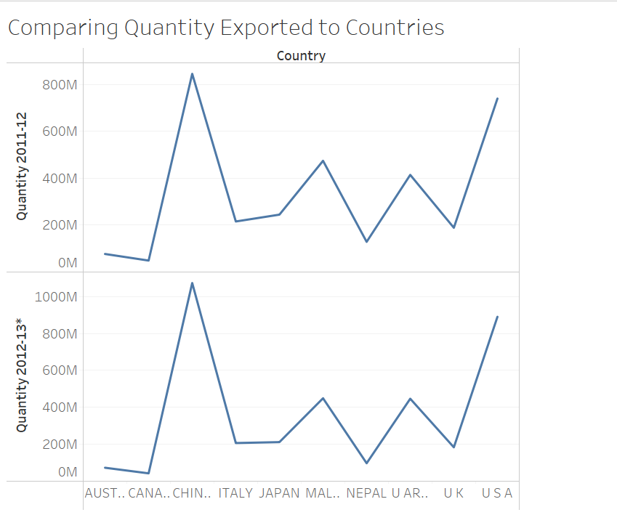

**7 Advantages and Disadvantages**

**7.1 Advantages**

* Help to significantly expand your markets exports
* Help to focus exports on commodities having higher Gains
* Greater production can lead to larger economies of scale and better margins.
* Exports could change existing products to suit new markets.
* trade analysis can help identify how materials are acquired and value is added by different nations.
* Export data from different regions may further provide insight into which nations are the highest exporters of certain goods, and can inform future strategies for acquiring intermediate or raw materials.

**7.2 Disadvantages**

* The Dataset is limited for a range of 4 years
* The project does not use a standardise unit for each country based on their currency
* Dataset has redundancy and cannot find month-wise export details.

**8 Applications**

* The project can be applied to Improve India’s foreign trade and boost the economy.
* These methods can also be applied in increasing the countries GDP.
* The project can also be applied in various other industry sectors such as banking automobile to improve sales.

**9 Conclusions**

The project successfully analysis exports of India with other countries. The exports patterns of india during years and with countries can be found. The commodity profits is also found for each country export.

**10 Future Scope**

* The proposed system can be used to find future trade patterns.
* It can also be extended to accommodate more data.